Hammer in the Community – Saturday 18th July 2026
Hammers we have secured a position at the community event in Ravenscourt Park on the 18th of July 2026. We will be promoting Hammersmith Chess Club as well as the benefits of over the board chess.
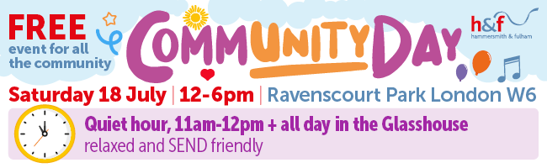
This will be tremendous opportunity for all Hammers to get involved. So, I need help to make sure the event runs smoothly.
Our set up time is from 11am. The event runs from 12 noon. We need to assemble at about 10am at the Mindsports Centre.
I need help with the following:
- I need to borrow a gazebo for the event – please email me if you can help.
- I need Hammers to help transport and set up the kit in the Park.
- I need Hammers to play chess against the general public and also help man the stand.
- I do not think we need a car.
- I need some Hammers who can play blindfold chess to impress the public.
So, time to get involved email me at jdrw9591@gmail.com ASAP.
John White
Events Officer

